# Comp 2322 Computer Networking

**Lab 1: Wireshark Introduction**

**Student Name: HE YIYANG**

**Student ID:22100143D**

Q1. 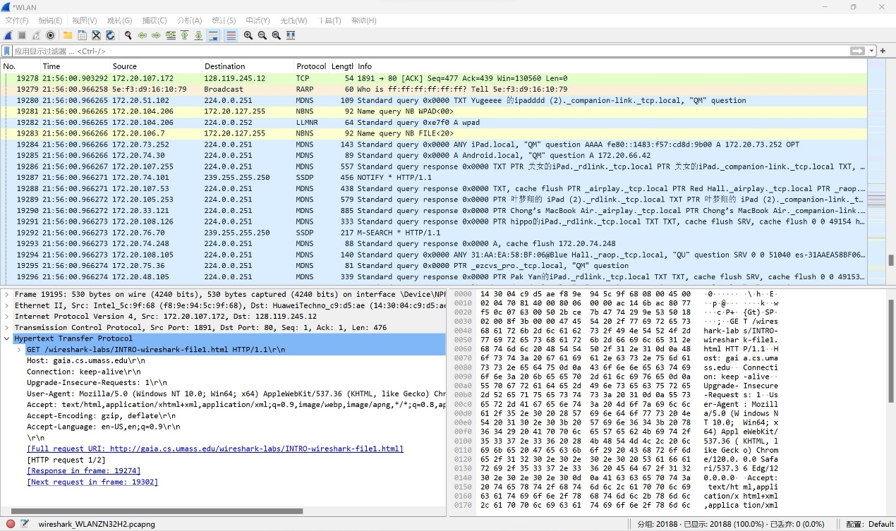

1. TCP 2. RARP 3. MDNS

Q2.

Method1:

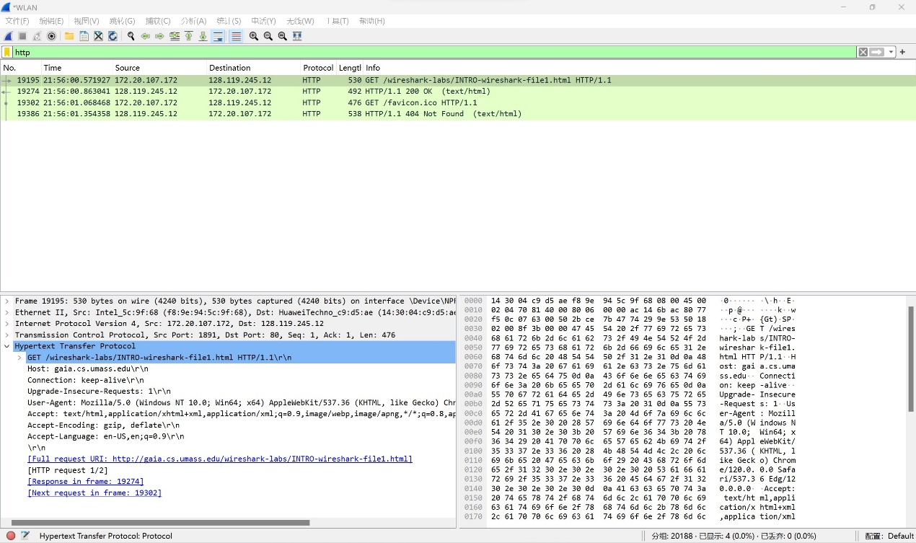

Timestamp of HTTP GET is 21:56:00.571927

Timestamp of HTTP OK is 21:56:00.863041

Time Taken = 21:56:00.863041 – 21:56:00.571927 = 0.291114s

Method2:

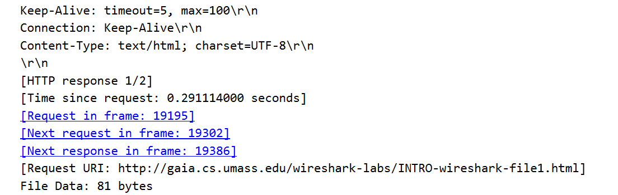

Time request is shown in the Hypertext Transfer Protocol of HTTP OK

Q3.



The Internet address of the gaia.cs.umass.edu is the Destination of HTTP GET, which is 128.119.245.12

The Internet address of my computer is the Source of HTTP OK, which is 172.20.107.172

Q4.

The last printed trace file shows the two HTTP messages

